**SALESFORCE PROJECT**

**MILKEASE**

* **Phase 3 :   Data Modeling & Relationships.**

👉 Goal **:** Build data structure.

* **Standard & Custom Objects**:-
* Standard :- Contact — customers (use Contact for consumer customers).

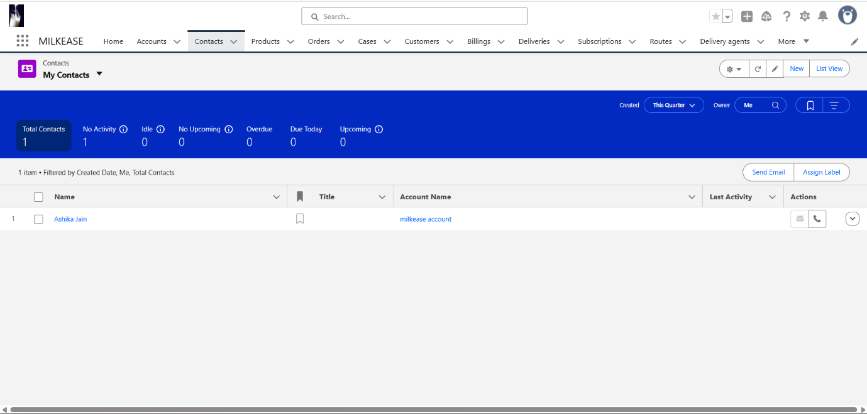

* Custom (minimum set for dairy):- Delivery Vehicle (maps from Vehicle)

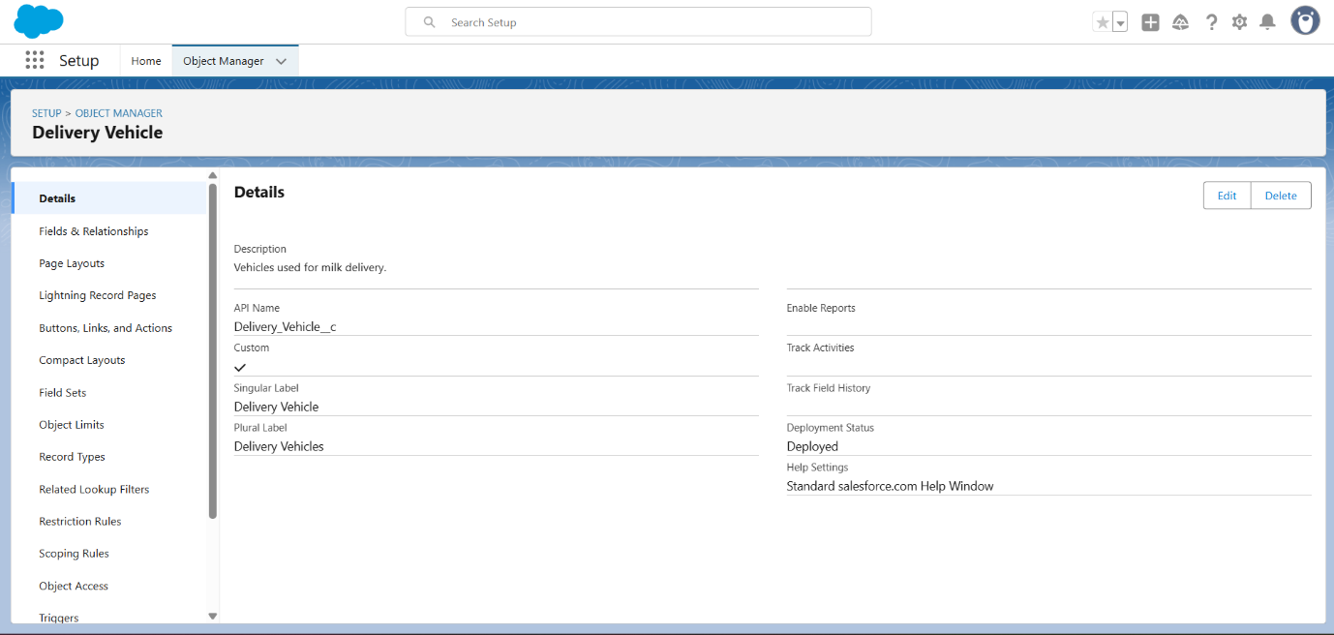

* **Fields**:-
* Delivery Vehicle :-

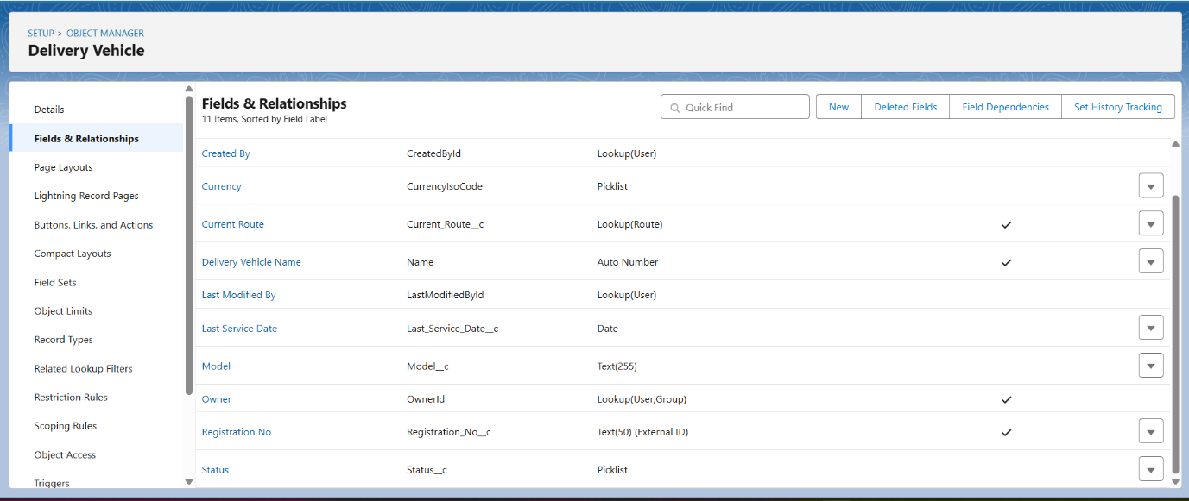

* Delivery Booking :-

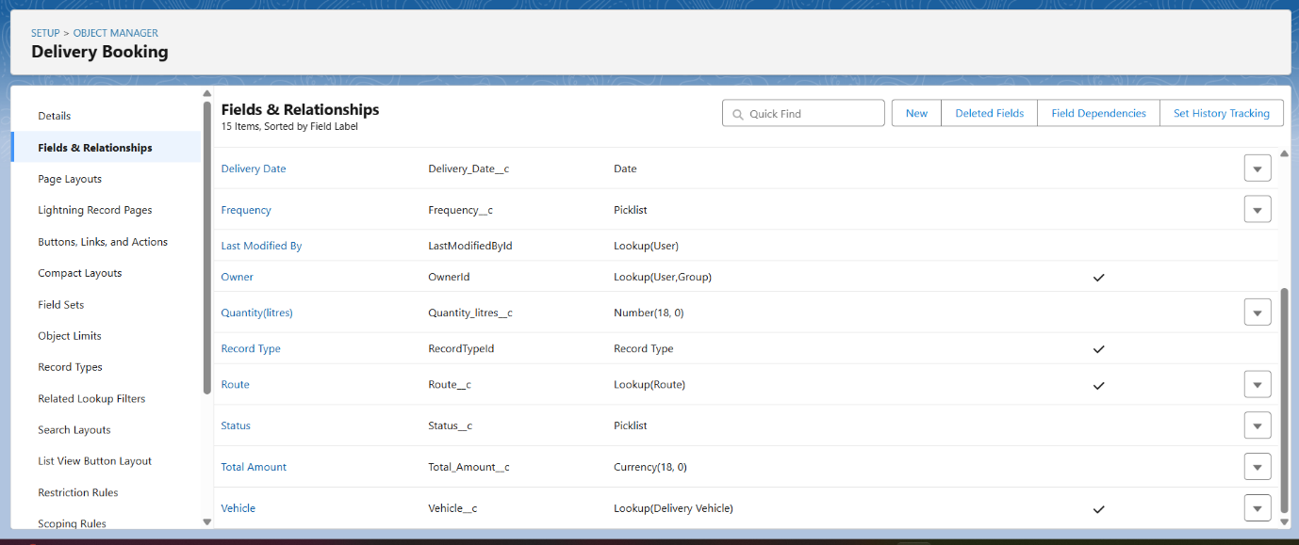

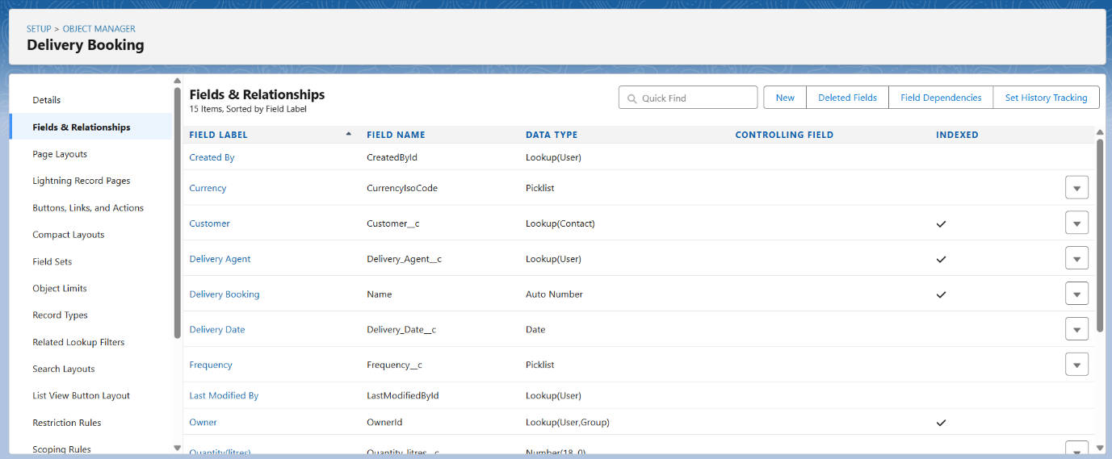

* **Record Types**:-
* Delivery Booking:- Daily **vs** Long-Term **vs** one time

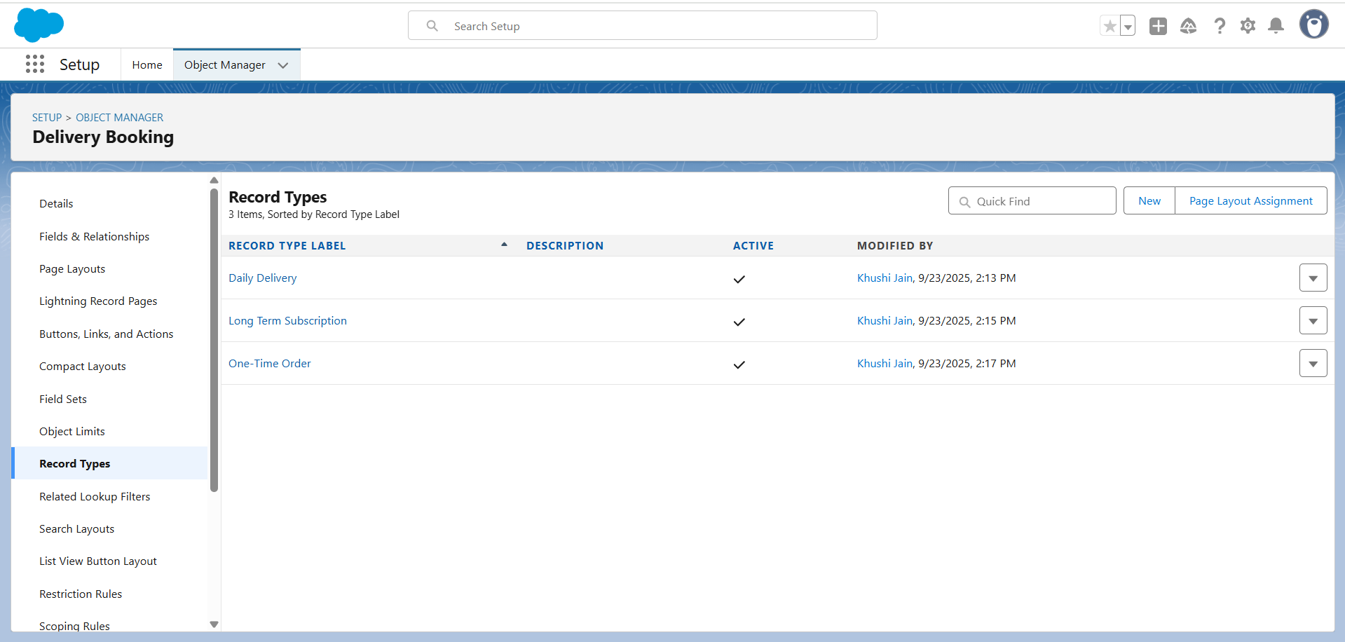

* **Page Layouts**:-
* Delivery Booking:- show related lists & booking history.

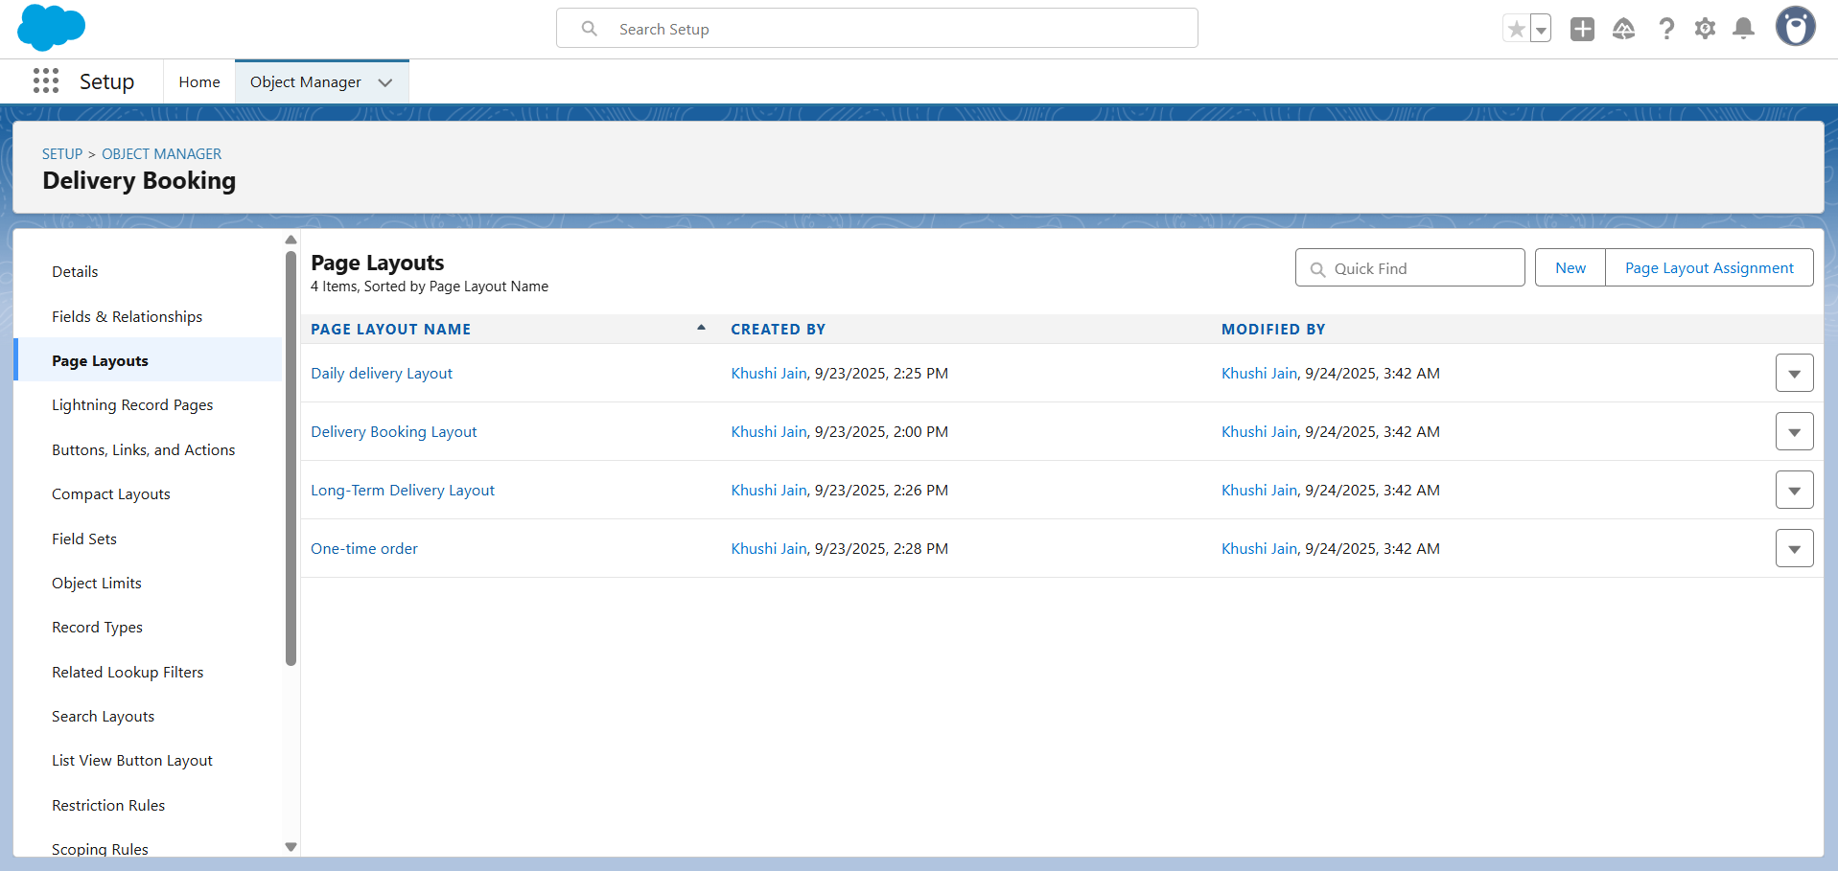

* **Compact Layouts**:-
* Mobile :- show related lists & booking history.

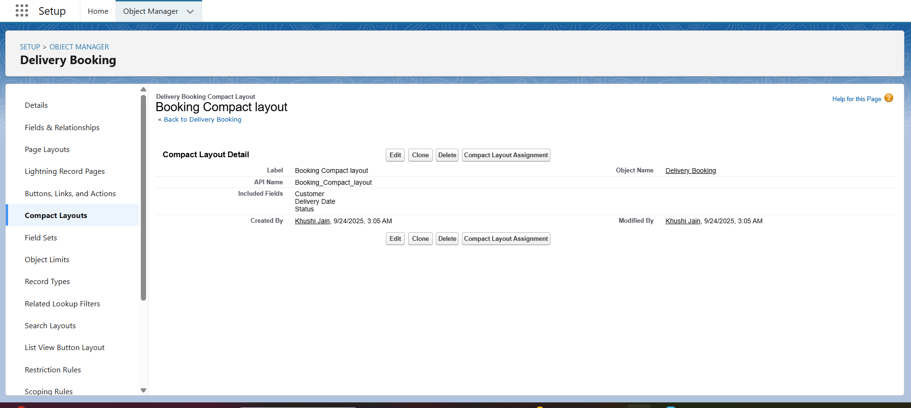

* **Schema Builder**:-
* Visual tool → draw relationships.

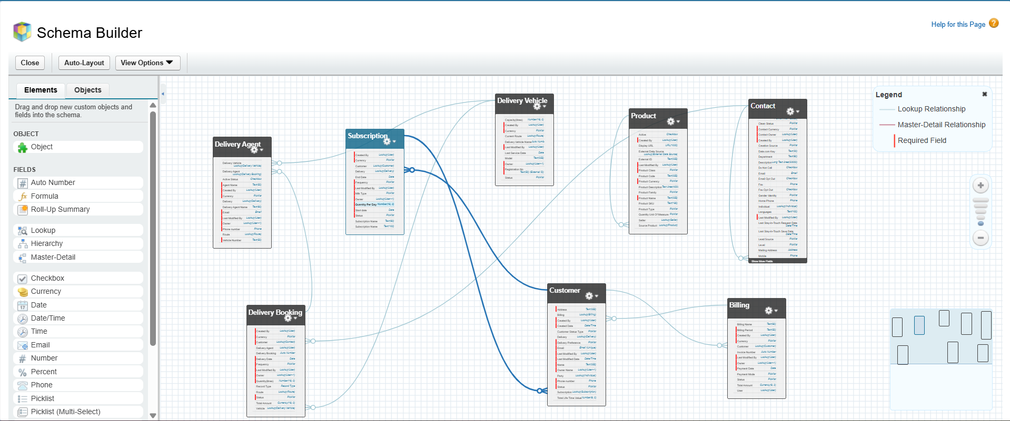

* **Lookup vs Master-Detail vs Hierarchical :-**
* **Delivery Booking :** Related To🡺 Delivery Vehicle

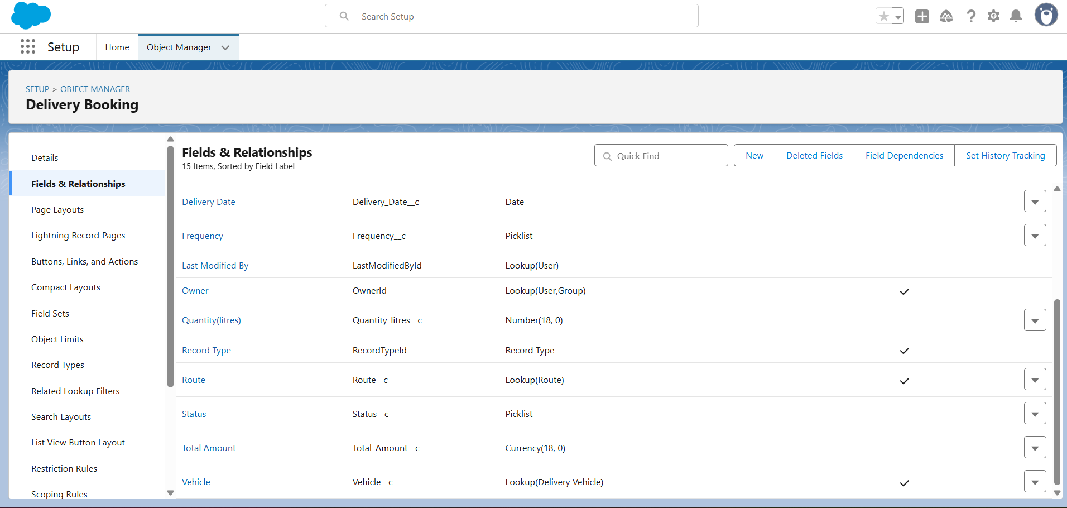

* **Booking Line Item :** Related To🡺 Delivery Booking (Master Detail Relationship)

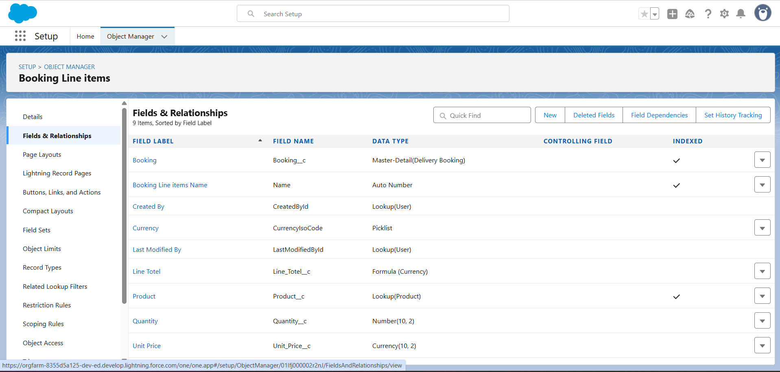

* **Junction Objects:-** If a booking can include multiple milk type , created Booking Line Item.

